Bahria University,

Karachi Campus



LAB EXPERIMENT NO.

**05**

LIST OF TASKS

|  |  |
| --- | --- |
| TASK NO | OBJECTIVE |
| 1 | **Write a program that throw double value and that value received by integer catch block. (hint: multiple catch block will be used, for example if you throw 55.5 value which is double value. Output; “Input is double value 55.5”).** |
| 2 | **Write a program that take three subject’s marks at runtime, if any input marks exceeded from 100, must throw exception, “input marks are invalid”.** |
| 3 | **Write a C++ program to perform arithmetic operations on two numbers and throw an exception if the dividend is zero or does not contain an operator.** |

Submitted On:

**26/12/2022**

**Task # 01: Write a program that throw double value and that value received by integer catch block. (hint: multiple catch block will be used, for example if you throw 55.5 value which is double value. Output; “Input is double value 55.5”).**

**Solution:**

#include<iostream>

#include<stdio.h>

#include<exception>

#include <cmath>

using namespace std;

int main(){

cout<<"Input any number:\n";

double num;

cin>>num;

try

{

if(floor(num)!=ceil(num)){

throw "Input value is double value ";

}

}

catch(const char *e)

{

cout<<""<<e<<num;

}

return 0;

}

**Output:**

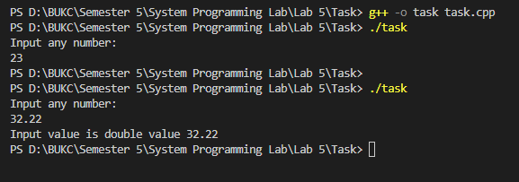

**Task # 02: Write a program that take three subject’s marks at runtime, if any input marks exceeded from 100, must throw exception, “input marks are invalid”.**

**Solution:**

int main()

{

int subject[3];

for(int i=0;i<3;i++)

{

cout<<"Enter Marks of Subject "<<(i+1)<<":"<<endl;

try

{

cin>>subject[i];

if(subject[i]>100)

{

throw "Input marks are invalid\n";

}

}

catch(const char *e)

{

cout<<""<<e;

}

}

return 0;

}

**Output:**

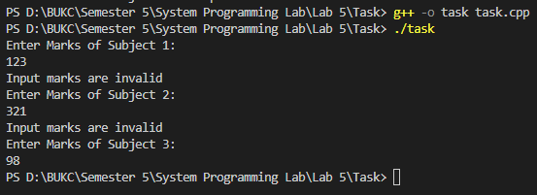

**Task # 03: Write a C++ program to perform arithmetic operations on two numbers and throw an exception if the dividend is zero or does not contain an operator.**

**Solution:**

int main(){

int n1,n2;

char oper;

int x=1;

while(x==1){

try

{

cout<<"Enter first Number: ";

cin>>n1;

cout<<"Enter Operator: ";

cin>>oper;

cout<<"Enter Second Number: ";

cin>>n2;

switch (oper)

{

case '+':

cout<<"Result:"<<(n1+n2);

break;

case '-':

cout<<"Result:"<<(n1-n2);

break;

case '*':

cout<<"Result:"<<(n1*n2);

break;

case '/':

if(n2==0){

throw "Number cannot be divided by zero\n";

}

else{

cout<<"Result:"<<(n1/n2);

}

break;

default:

throw "Invalid Operator";

break;

}

cout<<"\n";

}

catch(const char *e)

{

cout<<e;

}

cout<<"\n\nWant to calculate more?\n1)Yes\n2)No\nChoose: ";

int c;

cin>>c;

if(c!=1){

cout<<"Program ends Here";

break;

}

}

return 0;

}

**Output:**

